**Task 8: Generating & Compiling Maven in the Local Server Manually**

**MAVEN:**

Maven is a **build automation and project management tool** primarily used for Java projects. It simplifies the process of building, managing dependencies, and deploying applications by following a convention-over-configuration approach.

**Key Features of Maven:**

**Dependency Management:** Automatically downloads and manages project dependencies using a central repository.

**Build Automation:** Compiles source code, runs tests, packages the application, and deploys it with a single command.

**Standardized Project Structure:** Encourages a consistent structure for Java projects.

**Plugins:** Extensible with numerous plugins to support tasks like code analysis, documentation, deployment, etc.

**Project Information Management:** Maintains project metadata and reports.

**Ease of Integration:** Compatible with CI/CD pipelines and other tools like Jenkins.

Here, I have generated and compiled maven in my local server manually.

1. **We can get the Generating Maven Project script from “Maven in 5 Minutes” website.**

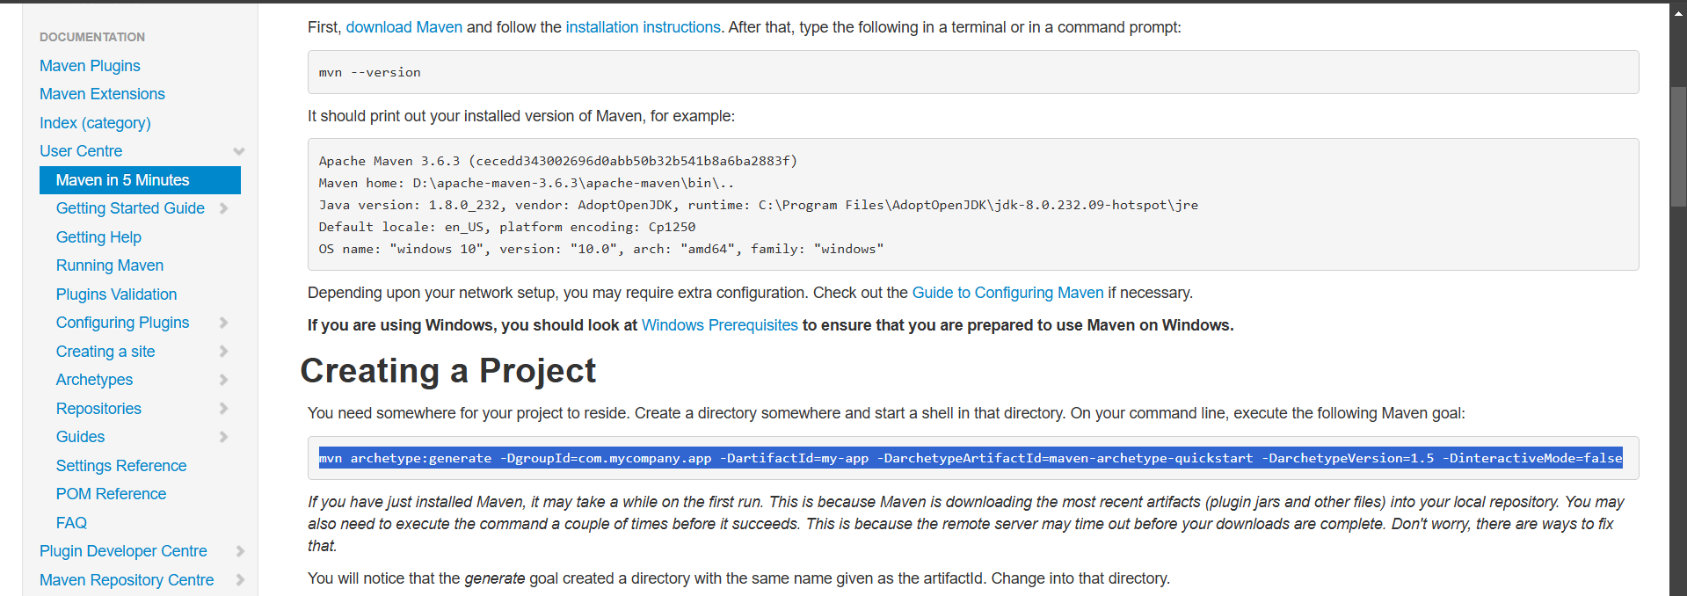

1. **Copy the script & Paste it in the command prompt of the local server**
2. **Change the App name if needed and here I have change the name as “Maven_app”**

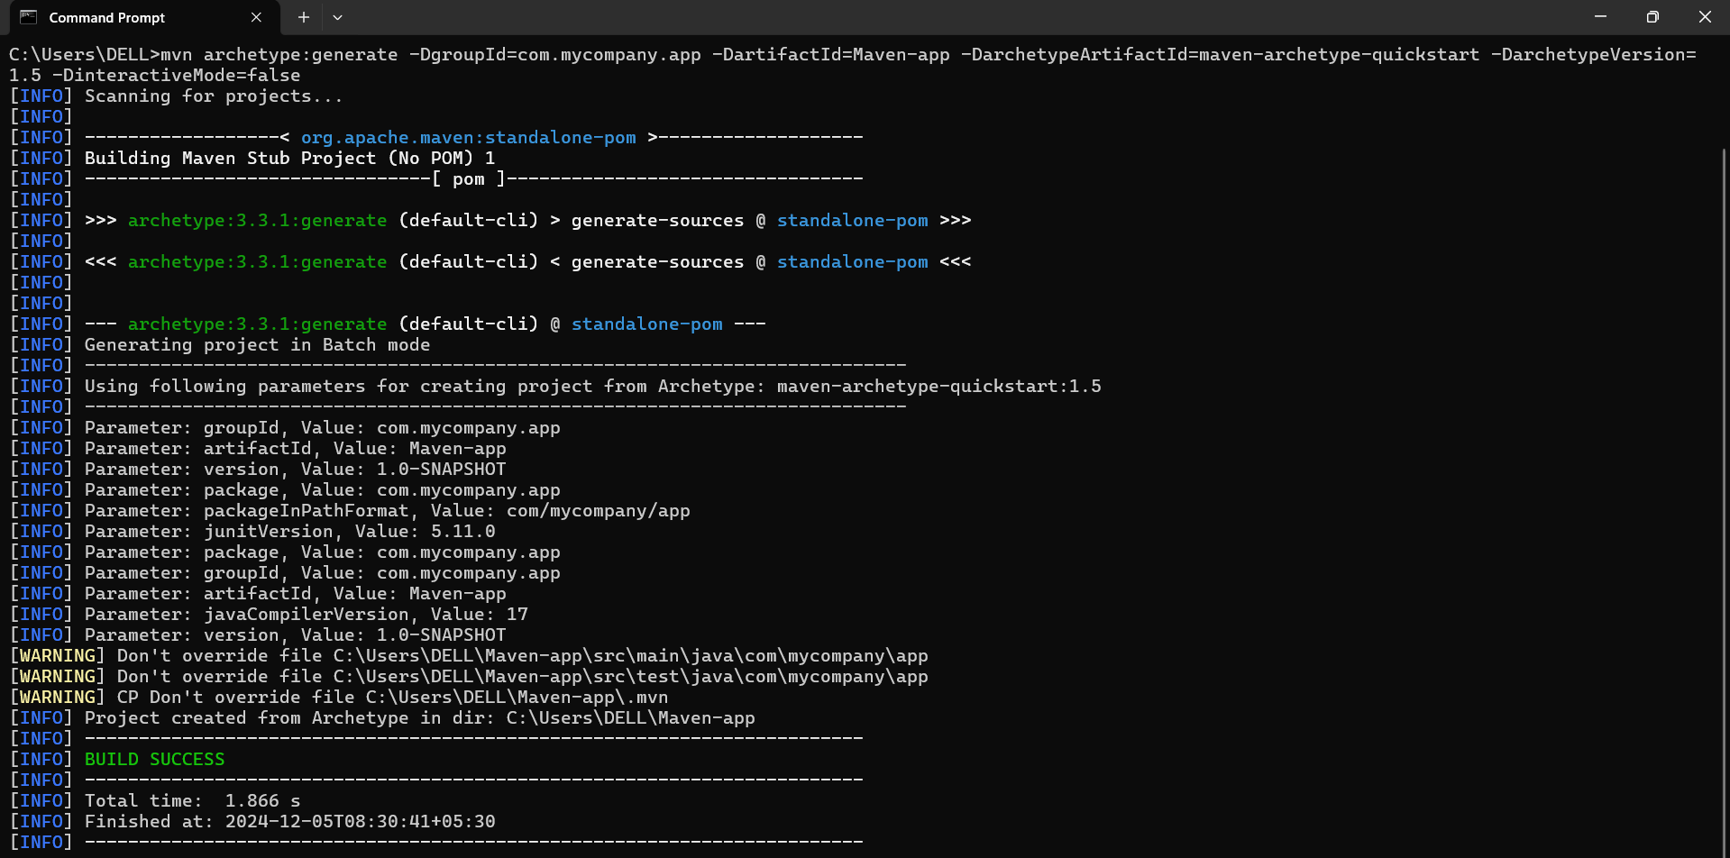

1. **The Maven app got generated successfully**



1. **The app has stored in the C:\Users\DELL\Maven-app path and it got placed along with the following 2 folders and 1 file**

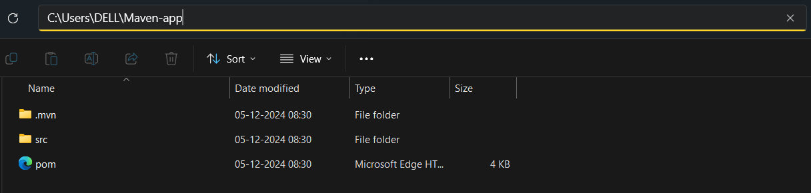

* The **.mvn folder** is a special directory in a Maven project that contains **Maven-specific configuration files**. It allows you to configure the behavior of Maven for a specific project without affecting the global Maven settings.
* The **src folder** is a standard directory in a Maven project that contains the project's source code, resources, and test files. It is an essential part of the **Maven Standard Directory Layout**, which organizes project files in a consistent structure. It Contains the main application code and resources.
* The **POM** (Project Object Model) is the fundamental configuration file in a Maven project. It is represented as an **XML file** named pom.xml, located in the root directory of the project. The POM defines the project’s structure, dependencies, build configuration, and more.

1. **Change the directory to the appropriate location and Compile the generated packages using “mvn compile” command**

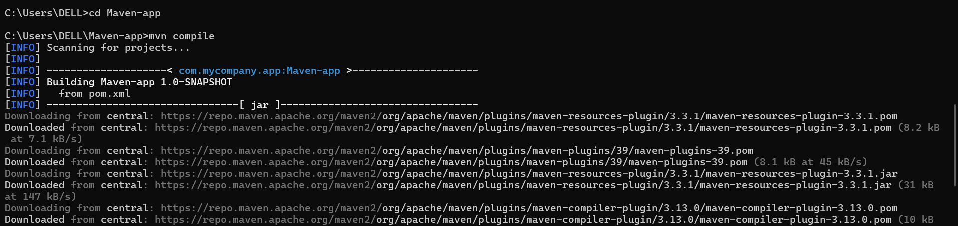

1. **The compilation has done successfully**

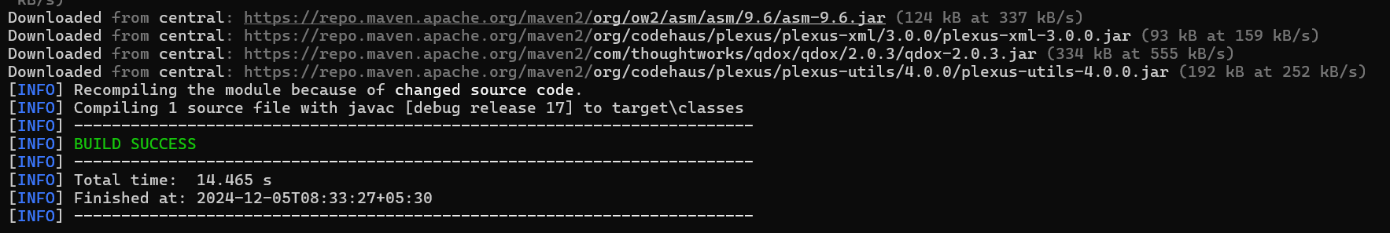

1. **As a result we will have a output folder named Target in the given location**

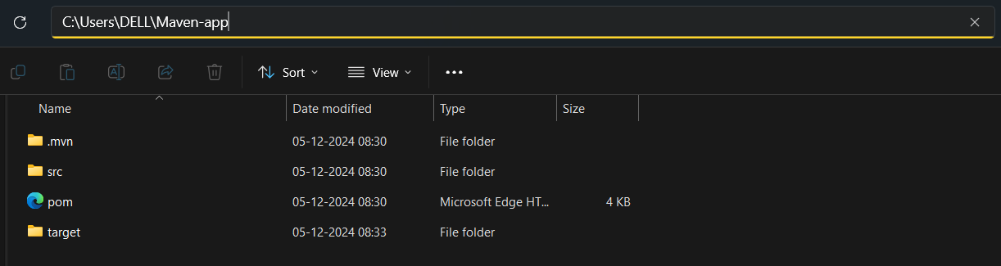

The **target folder** is a directory generated by Maven during the build process. It serves as the default output directory where Maven places all the compiled artifacts, packaged files, and other generated resources.

1. **Using “mvn clean” command we can delete the output folder**

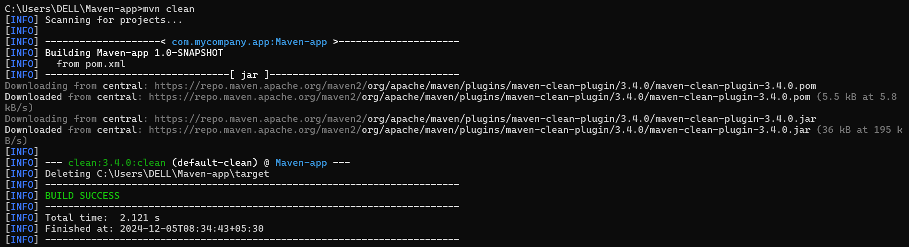

1. **The Target folder got deleted in the local server**

